Laser cut Plate preparation
- Laser cut the base plate(/3D-model/3D print and Laser cut file) from a 6mm MDF.
  - 6mm MDF board
  - Cut: base plate laser cut.dxf
  - Cut: j1 moving plate laser cut.dxf
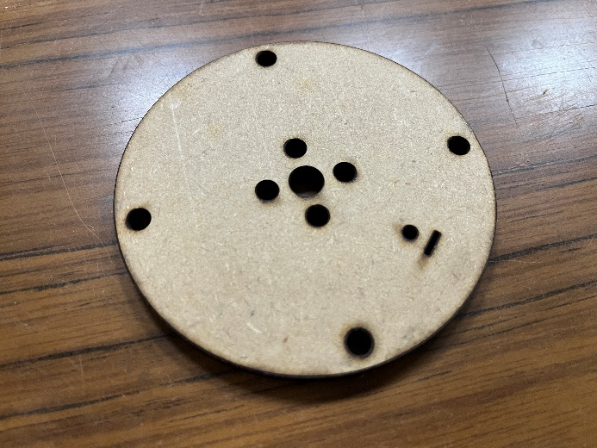
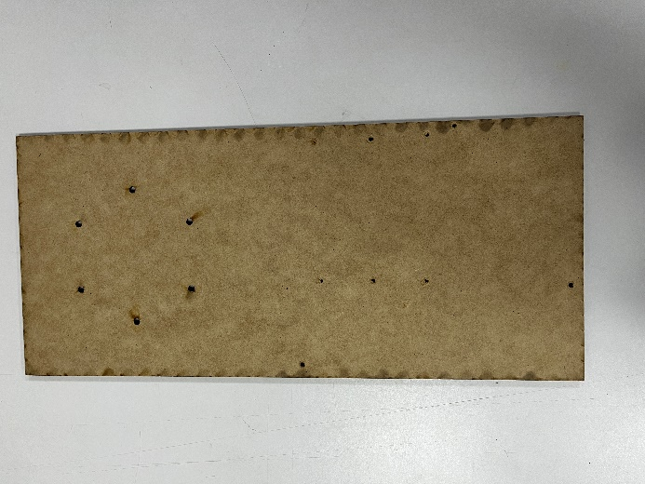

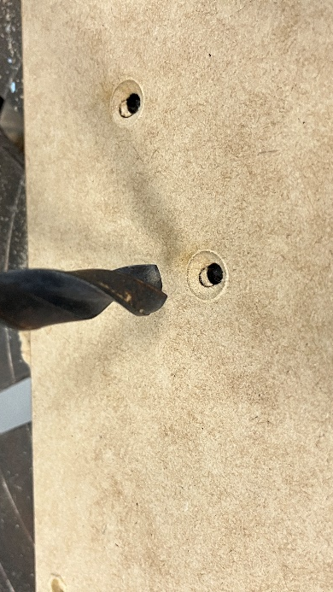

- Chamfer all the holes with a drill bit from the back side.
  - 12mm Drill bit

Wires preparation
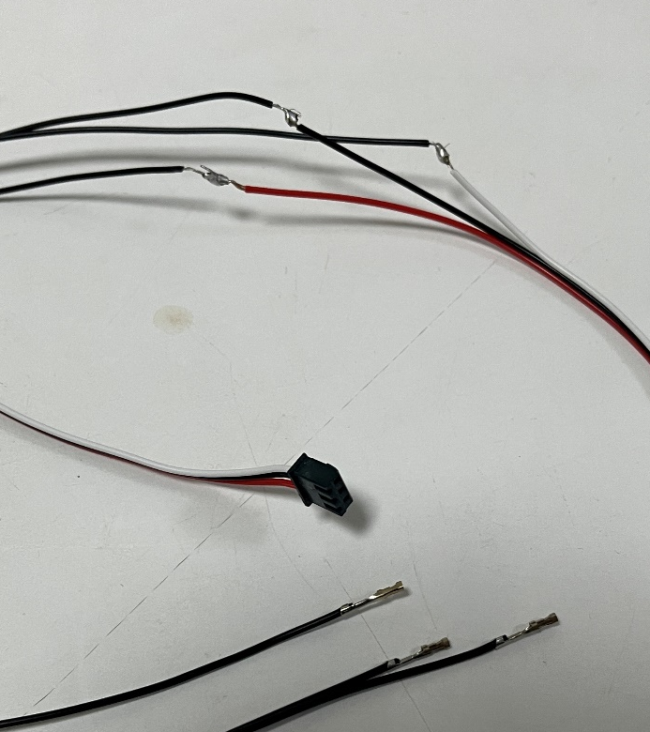
- Solder the optic endstop wire to a 3 pin Dupont 2.54mm pitch connector. There’re total of 5 optic endstop wire.
  - 3 pin Dupont 2.54mm pitch connector housing x 5
  - Dupont 2.54mm pitch connector wire x 15

- Solder Joint 4(28HS33 gear ratio 1:20), Joint 5(35BYGH20), Joint 6 (28HS34) motor’s wire to a 4 pin Dupont 2.54mm pitch connector.
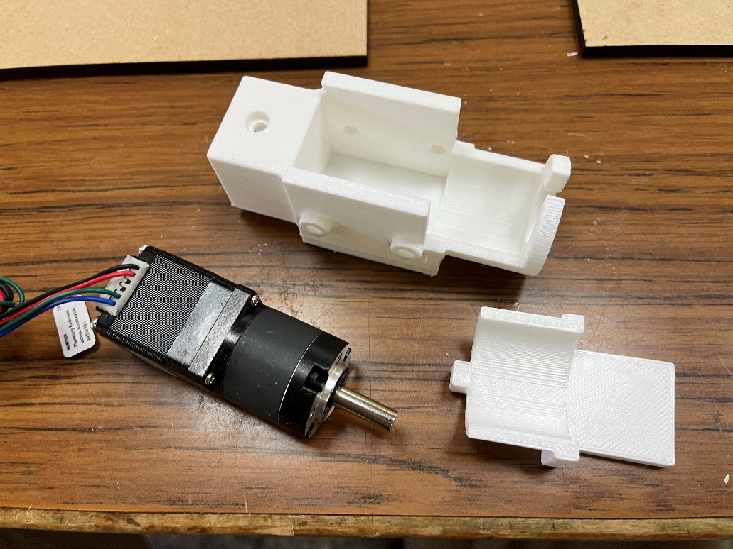
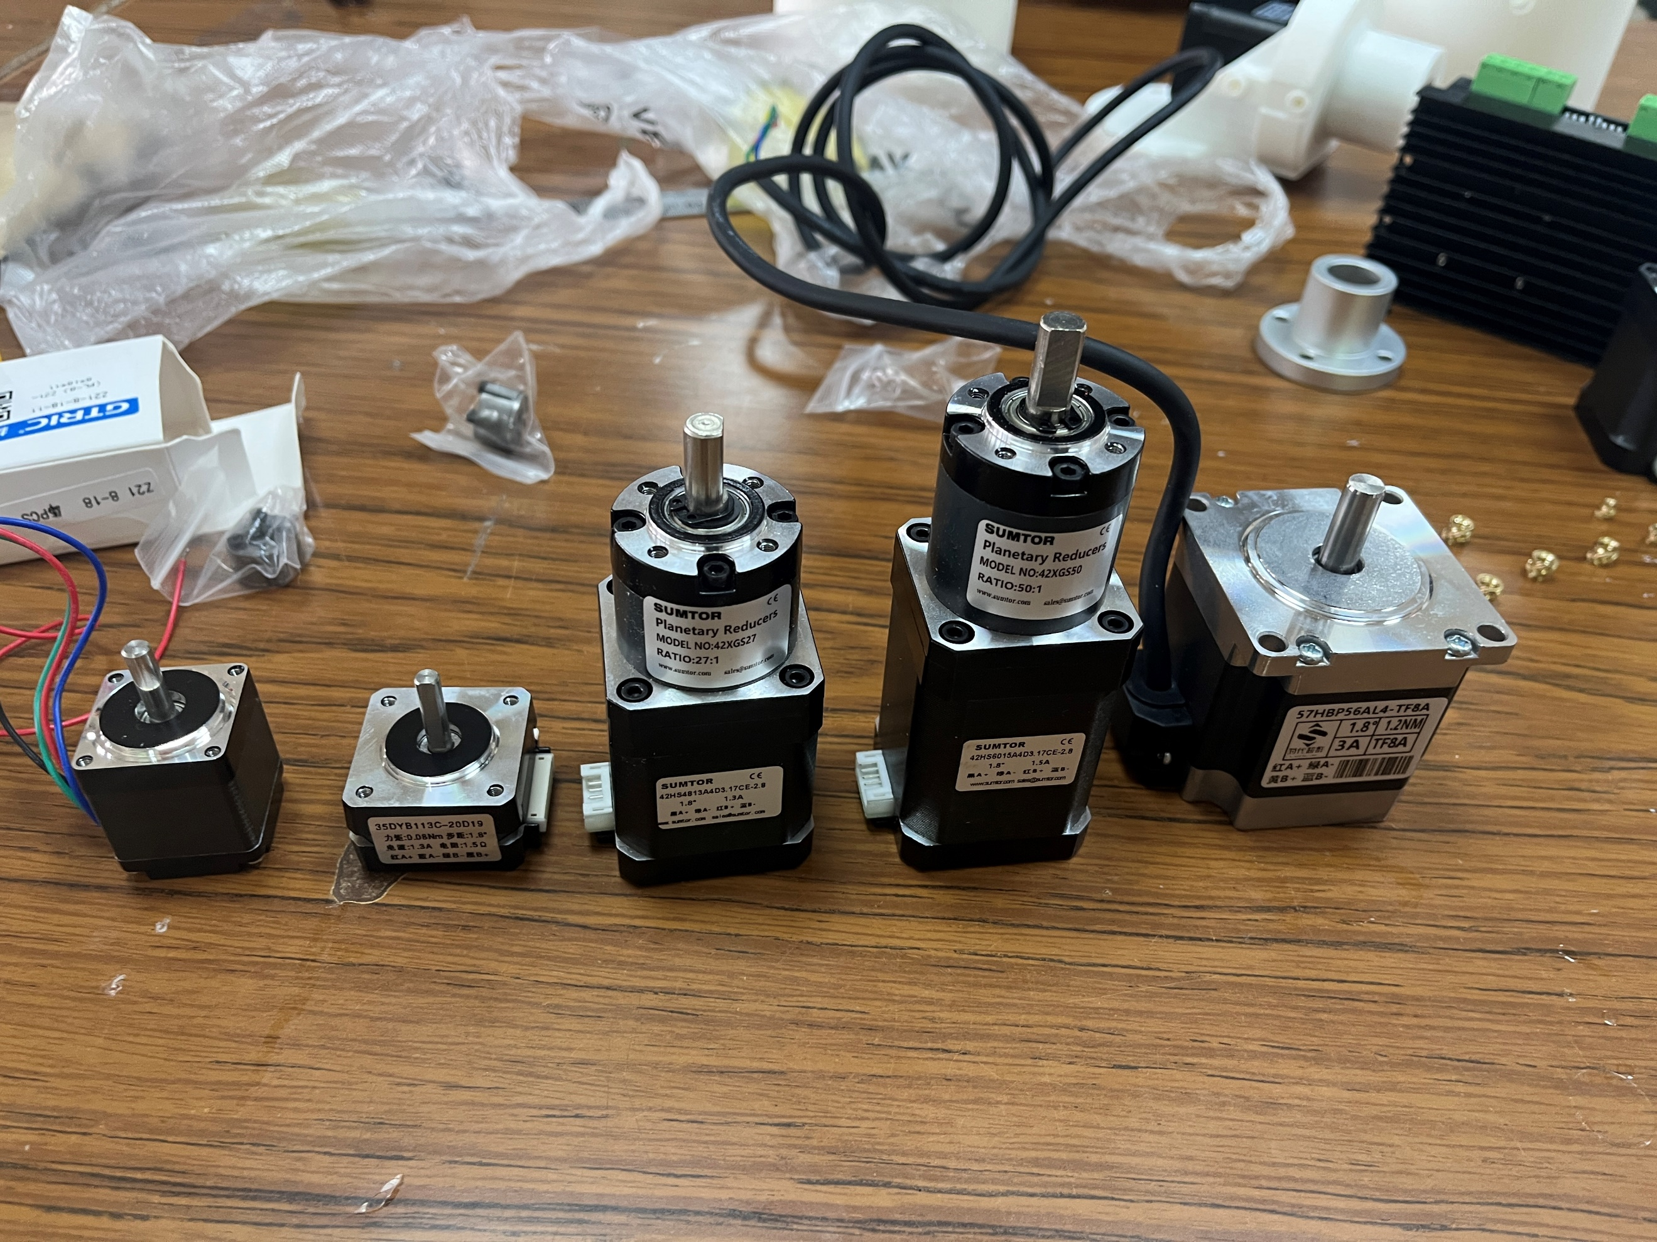
  - Specified motors
J6
J5
J4
  - Dupont 2.54mm pitch connector wire x 12(Red, Green, Blue, Black for readability)
  - 4 pin Dupont 2.54mm pitch connector housing x 3
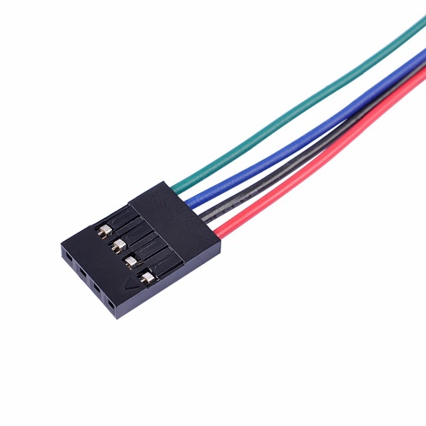

Joint 1 assembly
3D printed parts
- j1 57 mount.stl
- j1 endstop block v2.stl
- Tap M5 threads into 8mm coupling
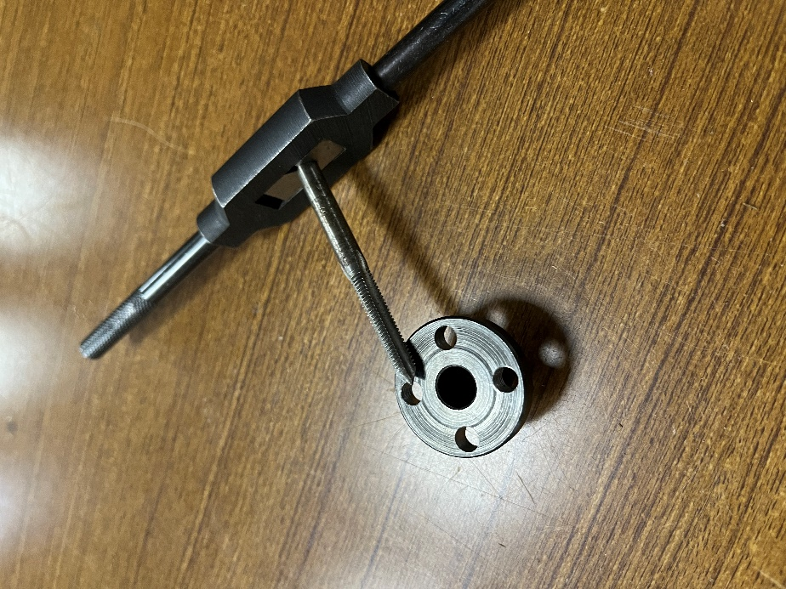
  - 8mm coupling
  - M5 Taps

- Install the Coupling on to the shaft of the NEMA 23 motor.
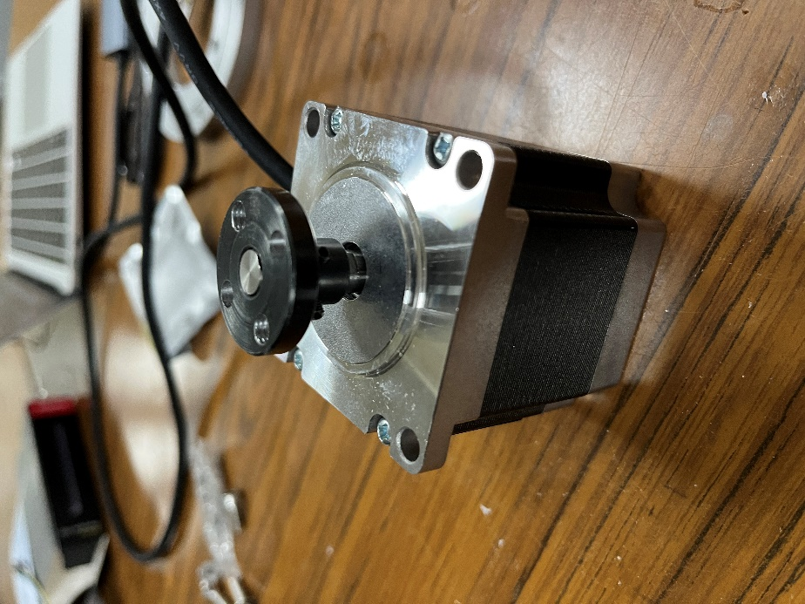
  - NEMA23 x 56mm
  - Tapped 8mm coupling

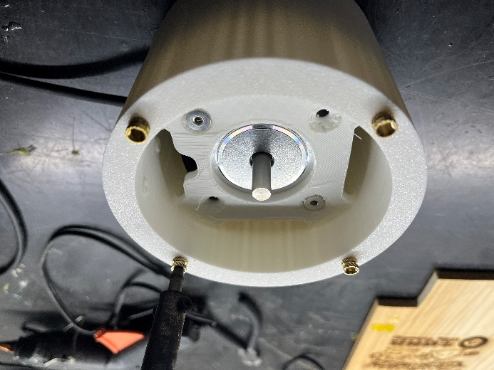
- Insert Hot Melt Insert Nut in () top and bottom side.
  - j1 57 mount
  - M5 Hot Melt Insert Nut x 10

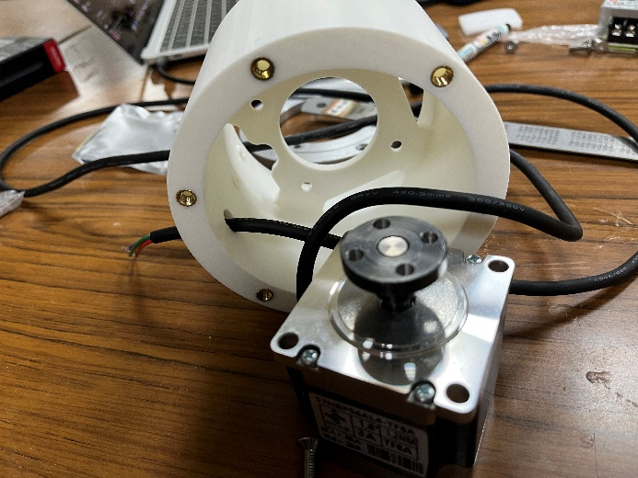
- Pass the wire if NEMA 23 motor through the hole on the mount

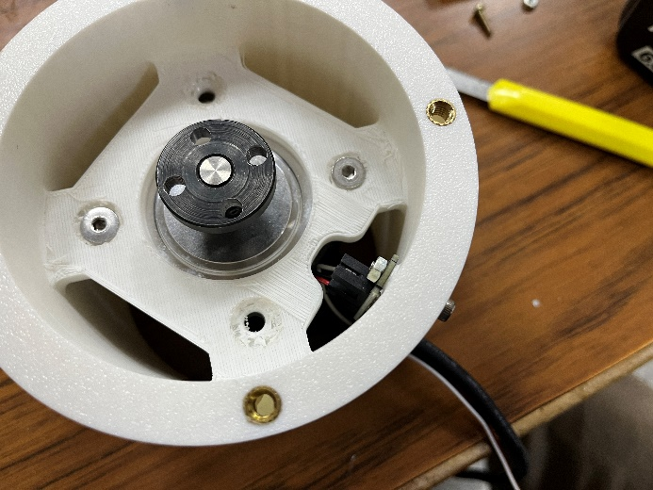
- Bolt in the motor onto the mount
  - M5 x 18 flat head bolt x 4
  - M5 nut x 4

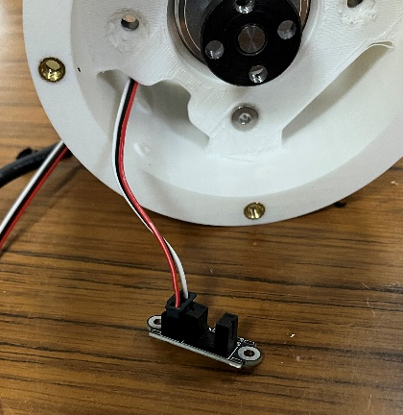
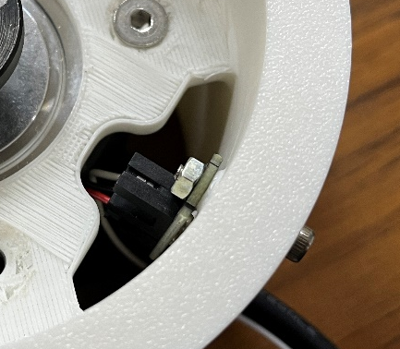
- Pass the endstop wire though the hole. Then bolt the optic endstop onto the mount.
  - Optic endstop x 1
  - 3 pin signal wire x 1
  - M3 x 22 round head x 2
  - M3 nut x 2

- Bolt endstop blocker onto j1 moving plate (chamfered side).
  - j1 endstop block v2
  - M3 x 12 round head bolt x 1
  - M3 nut x 1
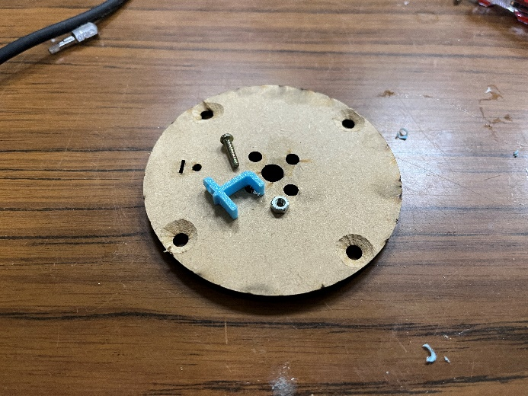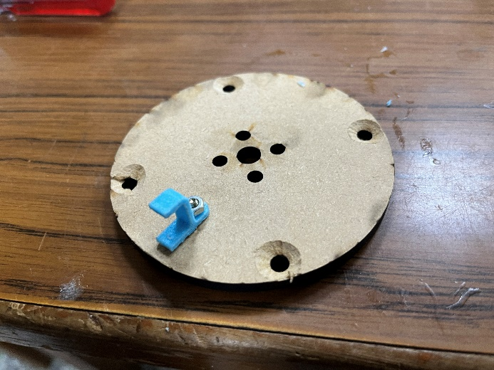
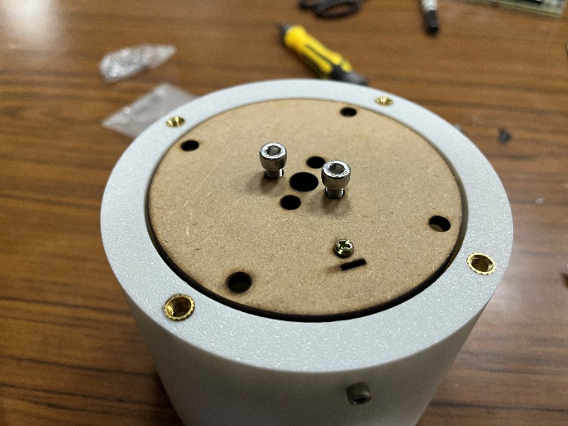
- Bolt the j1 moving plate laser cut board onto the 8mm coupling (endstop blocker down).
  - M5 x 8 round head x 4

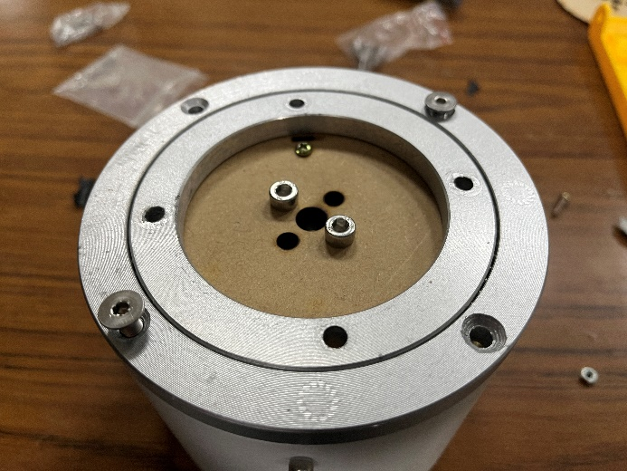
- Bolt the flat bearing on to the contraption
  - 120mm flat bearing
  - M5 x 18 flat head x 4

